INTRODUCTION
This assignment documents the development of a Library Management API system for Limkokwing University Library. The objective is to design and implement a basic digital system that allows library users to search for books, borrow and return books, track overdue books and fines, and support multiple users accessing the system simultaneously.

PART A: API Design
Four Endpoints for Limkokwing Library API
Endpoint 1: Search Books
GET /books/search
Aspect | Description
Purpose | Allow users and staff to search for books by title, author, or category to find available copies
Inputs | query (string) the search term  search by (string) can be "title", "author", or "category"
Outputs | JSON list of books with their ID, title, author, category, and available copies
Example:
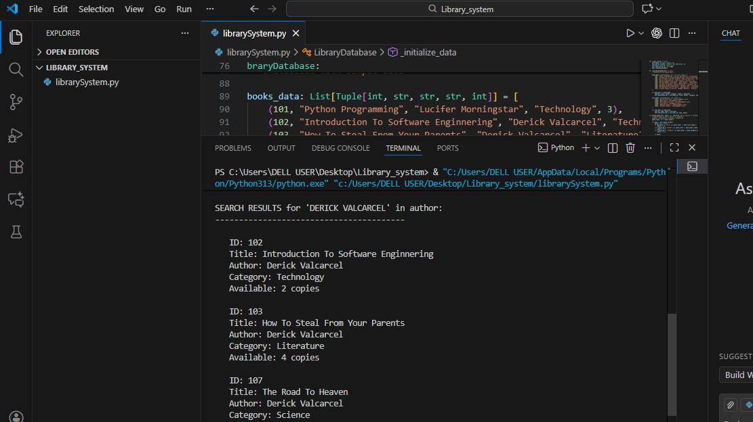
Endpoint 2: Borrow a Book
Post/Borrow
Aspect | Description
Purpose | Allow registered users to borrow an available book from the library collection
Inputs | User_id (integer) - the borrower's ID  Book_id (integer) - the book's ID  Borrow_date (string) - date in YYYY-MM-DD format
Outputs | Confirmation message with unique borrow ID and due date
Example:
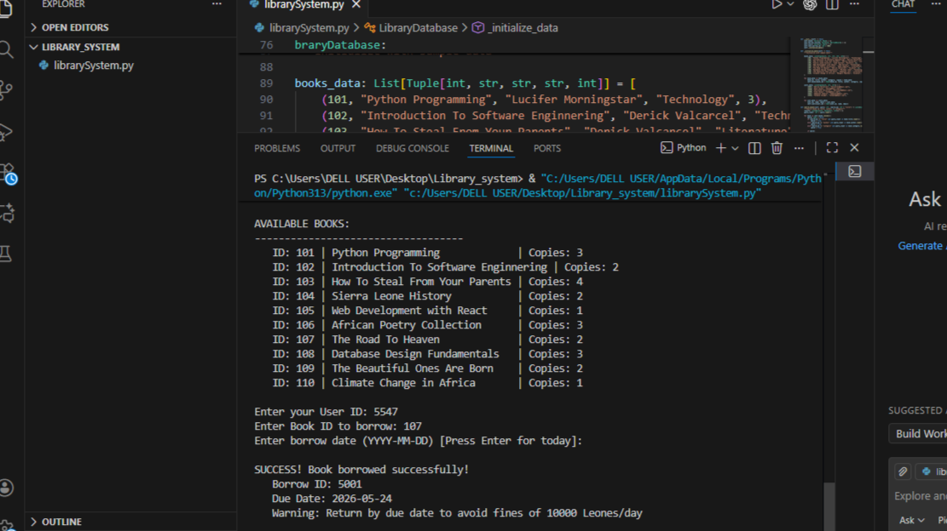
Endpoint 3: Return a Book
Post / Return
Aspect | Description
Purpose | Process book returns and automatically calculate any overdue fines
Inputs | Borrow_id (integer) - the unique borrow transaction ID  return_date (string) - date in YYYY-MM-DD format
Outputs | Confirmation message with fine amount if book is returned late
Example:

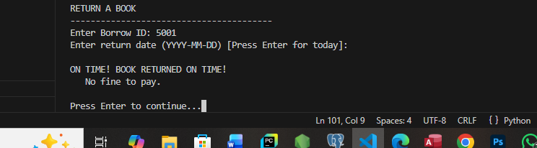
Endpoint 4: Get User Borrowing History
Get
Aspect | Description
Purpose | Track all books borrowed by a specific user including current loans and past returns
Inputs | user_id (integer) - passed in the URL path
Outputs | Complete list of borrow records for that user with dates and fine information
Example: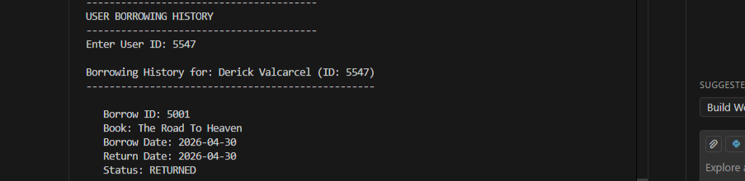

System Interaction Diagram

PART B: Implementation
Endpoint 1:
Endpoint 2:
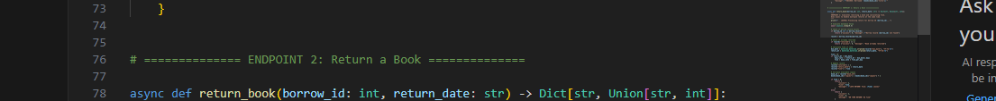Async and wait:

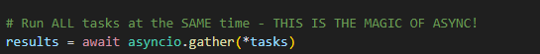
Type Annotations:
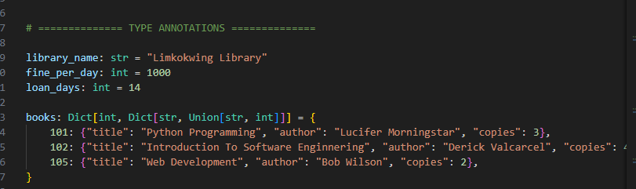
Output: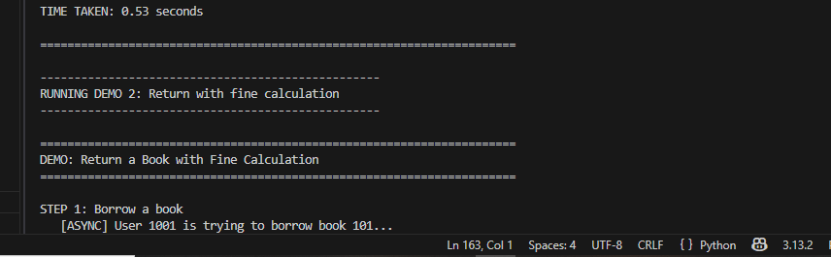
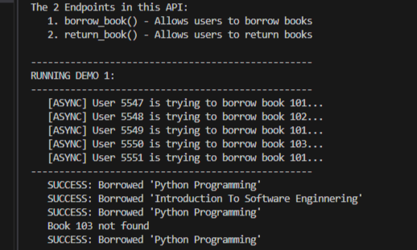
PART C: Reflection
How APIs Improve Efficiency in Limkokwing Library Services
APIs transform library operations by creating a standardized bridge between different software systems. At Limkokwing Library, an API would enable seamless integration between the library management system, student portals, mobile applications, and staff dashboards. Instead of manually updating records or using disconnected systems, staff can automate book searches, borrowing, returns, and fine tracking through API calls. This automation reduces human error, saves significant time, and allows real-time inventory updates. When a student borrows a book through the student portal, the API instantly updates availability across all systems simultaneously. Multiple staff members can access the same accurate data concurrently, eliminating duplicate work and ensuring consistent information throughout the university. This efficiency means students spend less time waiting and more time learning.
Alignment with SDG 4 - Quality Education
This assignment aligns with Sustainable Development Goal 4, which aims to ensure inclusive and equitable quality education and promote lifelong learning opportunities for all. The problem statement addresses the critical need for an efficient library system that supports learning. Libraries are fundamental to education as they provide access to knowledge resources essential for academic success. By creating an API that simplifies book searching, borrowing, and tracking, this project directly supports SDG Target 4.a, which calls for building and upgrading education facilities that are effective learning environments for everyone. A digital library API removes barriers to accessing educational materials, ensuring students spend less time searching for books and more time actually learning. The efficient system also supports lifelong learning by making resources more accessible to both students and staff, regardless of their technical expertise.
Challenges Faced
The main challenge was handling multiple concurrent requests for borrowing the same limited book copies. Without proper asynchronous implementation, race conditions would occur where two users could borrow the last copy simultaneously. I solved this using async/await with proper transaction handling. Another challenge was structuring JSON responses that clearly communicate fine calculations and overdue status without overwhelming users with technical details. I also struggled with date handling for fine calculations across different formats, ensuring consistent calculation of late days. Testing async code locally was difficult since I had to simulate delays realistically to demonstrate the performance benefits of concurrent processing.
Suggested Improvement for Library Expansion
If the library expands to multiple campus locations across Sierra Leone, I would add a centralized authentication system using JWT tokens for secure access across all campuses with different permission levels for students, staff, librarians, and administrators. Additionally, a real-time notification system using WebSockets could automatically notify users when reserved books become available or when books are overdue, significantly reducing late returns and improving resource utilization across the expanded library network.

CONCLUSION
In conclusion, this assignment successfully demonstrates the development of a Library Management API system that meets all the requirements specified by Limkokwing University Library. The proposed four endpoints (search books, borrow book, return book, and view user history) provide a complete solution for basic library operations.

